Lab: Data Operations in Django with Queries
Submit your solutions to the SoftUni Judge system.

For this lab, you are given an ORM project skeleton (you can download it from the current lesson's resources) with one model called "Student". It consists of the fields: "student_id", "first_name", "last_name", "birth_date", and "email".
- Make sure your model imports are following the Django setup part in the caller.py file!
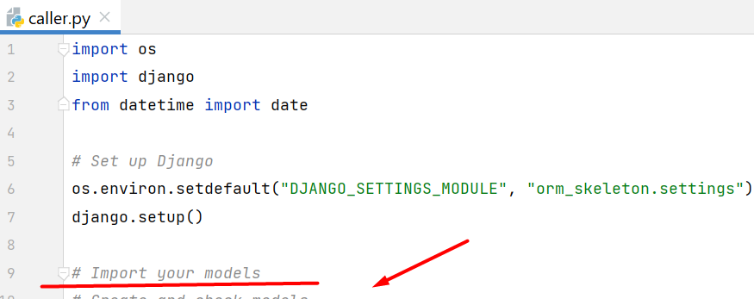

Add Students
Create a function called "add_students" that adds the given records to the students' database table:
student_id | first_name | last_name | birth_date | email
FC5204 | John | Doe | 15/05/1995 | john.doe@university.com
FE0054 | Jane | Smith | null | jane.smith@university.com
FH2014 | Alice | Johnson | 10/02/1998 | alice.johnson@university.com
FH2015 | Bob | Wilson | 25/11/1996 | bob.wilson@university.com
Note: Practice using both methods of adding records to the database.

Examples
Test Code
add_students()
print(Student.objects.all())
Output
<QuerySet [<Student: John Doe>, <Student: Jane Smith>, <Student: Alice Johnson>, <Student: Bob Wilson>]>

Get Students Info
Create a function called "get_students_info" that returns all students's records from the database in the format:
"Student №{student_id}: {first_name} {last_name}; Email: {email}
...
Student №{student_id}: {first_name} {last_name}; Email: {email}"

Examples
Test Code
print(get_students_info())
Output
Student №FC5204: John Doe; Email: john.doe@university.com
Student №FE0054: Jane Smith; Email: jane.smith@university.com
Student №FH2014: Alice Johnson; Email: alice.johnson@university.com
Student №FH2015: Bob Wilson; Email: bob.wilson@university.com

Update Students' Emails
Create a function called "update_students_emails" that updates all students' emails. The current email domain is "university.com". Your task is to change it to "uni-students.com".

Examples
Test Code
update_students_emails()
for student in Student.objects.all():
print(student.email)
Output
john.doe@uni-students.com
jane.smith@uni-students.com
alice.johnson@uni-students.com
bob.wilson@uni-students.com

Truncate Students
Create a function called "truncate_students" that deletes all students' records from the database table.

Examples
Test Code
truncate_students()
print(Student.objects.all())
print(f"Number of students: {Student.objects.count()}")
Output
<QuerySet []>
Number of students: 0

